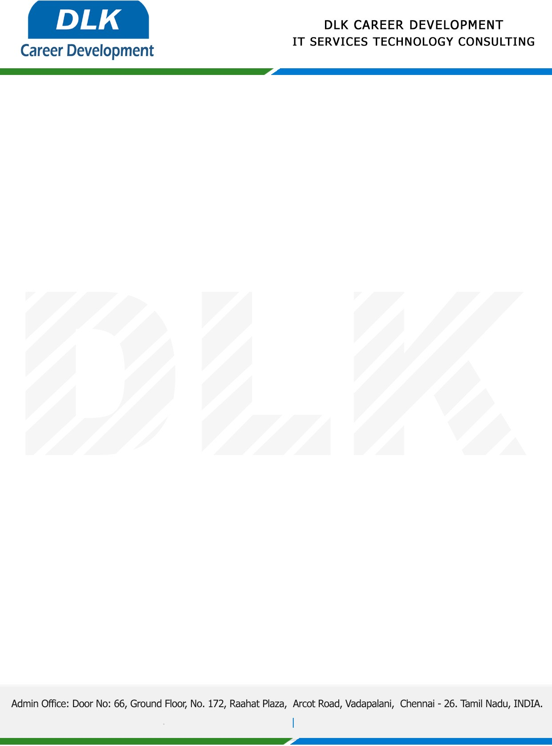

**Date: 27/April/ 2023**

**SUB: PROJECT COMPLETION CERTIFICATE**

This is to certify that **MR Paul Thuyavan D** **(REG NO:** **2113092037123)** **MCA -PG & Research Department Of Computer Application,** final year student at **Dwaraka Doss Goverdhan Doss Vaishnav College(Autonomous), Arumbakkam, Chennai** has Successfully Completed his Project Work under the domain of “**PYTHON”** in our organization during the Period **(2nd January to 27th April 2023)**

**Topic**: Classification of Diabetic Retinopathy and Retinal images using VGG16 and SVM

We appreciate your interest in **DLK CAREER DEVELOPMENT**

**“Best Wishes for Your Future Endeavors “**

